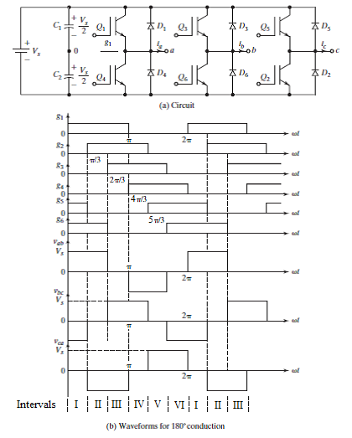

**Fig. 3.20 Three phase 6 step 180 mode bridge inverter**

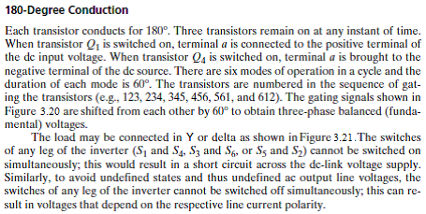

**RY = RΔ/3**

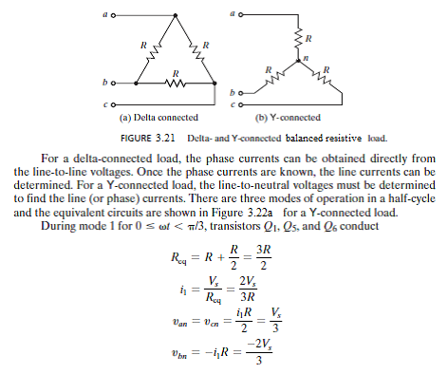

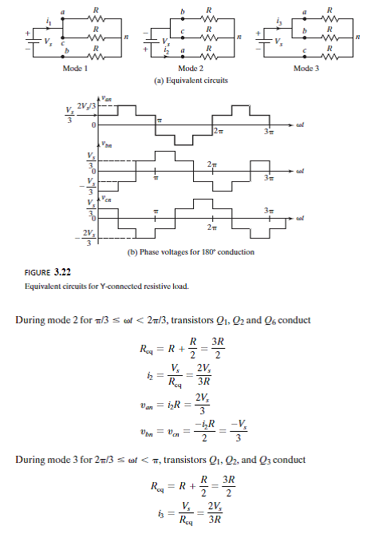



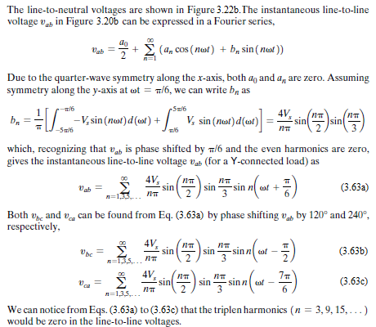

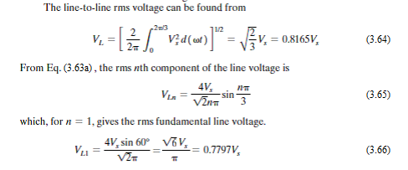

The line-to-neutral voltages in Figure 3.22 can be expressed in a Fourier series as:



$$v_{an}=\sum_{n=1,5, 7…}^{∞}{\frac{2V_{s}}{nπ}\sin{nωt}} (3.67)$$

$$v_{bn}=\sum_{n=1,5,7…}^{∞}{\frac{2V_{s}}{nπ}\sin{ \left(n\left(ωt-\frac{2π}{3}\right)\right) }} (3.68)$$

$$v_{cn}=\sum_{n=1,5,7…}^{∞}{\frac{2V_{s}}{nπ}\sin{ \left(n\left(ωt+\frac{2π}{3}\right)\right) }} (3.69)$$

The rms value of the fundamental line-to-neutral voltage can also be obtained from the corresponding line-to-line voltage as:

VP1 = = 0.4502Vs (3.71)

Thus it is seen that for 180º mode, the **line-to-line** output voltage is a **quasi-square wave** with amplitude of +/- Vs and pulse width of 120º, while the **phase** output voltage is a **six step** waveform with amplitudes of +/- 1/3Vs and +/- 2/3Vs.

This can be compared with 120º mode where it is seen that the **phase** output voltage is a **quasi-square wave** with amplitude of +/- Vs/2 and pulse width of 120º, while the **line-to-line** output voltage is a **six step** waveform with amplitudes of +/- Vs/2 and +/-Vs.